**

SQL Diagnostic Manager

9/8/11

Proprietary and Confidential to BBS Technologies, Inc.

©2011 BBS Technologies, Inc.; all rights reserved.

# Revision history:

|  |  |  |
| --- | --- | --- |
| **When?** | **Who?** | **What?** |
| 9/5/2011 | Robert Wilkinson | First Draft |

# Table of Contents

1. Revision history: ii

2. Table of Contents iii

3. Requirements 1

3.1. Overview/Purpose 1

3.2. Target Users 1

3.2.1. Related Customer Requests 1

3.3. Competitive Considerations 1

3.4. Use Cases 1

3.4.1. Current Behavior 2

3.4.2. Proposed Behavior 2

3.5. Feature/Function Market Requirements 2

3.5.1. Required Functions 2

3.5.2. Removed Functionality 3

3.5.3. Non-Supported Functions 3

3.6. FAQ 4

3.7. Open Issues 4

4. Functional Design 5

4.1. User Interfaces 5

4.2. Installation and Upgrade 11

5. Architecture 12

5.1. Overview 12

5.2. Interaction with SQLdm Components 12

5.2.1. Desktop Client 12

5.2.2. Repository 12

5.2.3. Management Service 12

5.2.4. Collection Service 13

5.2.5. Predictive Analytics Service 14

5.2.6. Reporting 14

5.2.7. Custom Counters 14

5.2.8. SQLdm Mobile 14

5.2.9. Idera News Feed 14

5.2.10. Powershell Integration 14

5.3. Supported SQL Server Versions and Editions 15

5.4. Install and Upgrade 15

5.5. Permissions and other Required Configuration 15

5.5.1. SQLdm Application Security 15

5.5.2. Other Security Considerations 15

5.6. Licensing Issues 15

5.7. Dependencies 15

5.7.1. Dependencies on Idera Software 15

5.7.2. Third-Party Software Required on the Customer Machine 15

5.7.3. Third-Party Software Required Internally 15

6. Schedule 16

6.1. Schedule 16

6.1.1. Work Breakdown and Sizings 16

6.1.2. Areas of Schedule Risk 16

7. Quality Assurance Considerations 17

7.1.1. Overview 17

7.1.2. Areas of Special Risk 17

7.1.3. Platform Considerations 17

7.1.4. Test Requirements 17

8. Documentation Considerations 19

9. Bibliography and Works Cited 20

# Requirements

## Overview/Purpose

The ability to view the plan of a query is very important for diagnosing poorly performing queries. Adding query plans to SQLdm will greatly aid in the user’s ability to fix the broken queries.

## Target Users

The target user is a person that is diagnosing poorly performing queries.

### Related Customer Requests

14656 – FRQ: You should be able to collect execution plan information for queries captured by query monitor.

14452 – Customer would like the execution plan to appear in the Queries view

## Competitive Considerations

Both Quest and SQL Sentry display query plan information. SQLdm does not. This puts us behind competitively.

1. Quest only displays the query plan XML. It does not provide any other distillation of the plan data. This is not very helpful. There is more information in SSMS.
2. SQL Sentry displays a nicely distilled view of the query plan. It provides performance data (reads, writes, etc.) about the query as well as an updated plan diagram. However, they only query the plan cache every collection interval so there is a very high chance that they will not get many of the plans.

## Use Cases

1. Users will be able to view query plan xml.
2. Users will be able to view the query plan diagram.
3. Users will be able to view the query plan details.
4. Users will be able to view the differences between different query plans for the same query.
5. Users will be able use the same filters criteria that is available for Signature and Statement mode.
6. Users will be able to view historical query plans.
7. Users will be able to compare plans using plan diagrams
8. Users will be able to compare plans using top plan operations
9. Users will be able to view a query plan from the procedure cache view.

### Current Behavior

#### Current SQLdm Use Case

Users cannot currently view query plans.

#### Competitive Use Cases

Users can currently use SSMS, SQL Sentry Performance Advisor or SQL Sentry Plan Explorer to view query plans for query analysis.

### Proposed Behavior

SQLdm will provide the ability to view query plan information as a part of the query monitor.

## Feature/Function Market Requirements

### Required Functions

* Provide a new view that will display query plan information. This view will be a part of the query monitor. It will be like the Query History view in that it will only display data about one query.
* Display all the plans for a query. This will be done in a grid and will list key data items about the plan such as cost, reads, writes, etc.
* Provide a historical view of the data. The plans will be stored historically and be viewable via the history browser.
* Display a plan diagram for each plan.
* Display the Top Operations for a plan. This will list the top five most expensive operations in the plan. Five is just a random number. We could list 5, 10, all of them or any number. The key is to sort them based on Estimated Cost of the operation.
* Display the Query Plan XML.
* Display all the returned columns for a plan.
* Display the details of each plan. This will be a right click option.
* Provide the ability to show differences between two plans. The user will select two plans and view the differences.
* When showing differences, show both plan diagrams and Top Operations
* Provide the ability to opt out of gathering plan information in the query monitor settings.
* Change the Procedure Cache view to provide a link to the query plan if we have captured one.

### Removed Functionality

None.

### Non-Supported Functions

This feature will not be available for SQL Server 2000. The query plan DMVs do not exist for SQL Server 2000.

#### Potential Future Functionality

There is some speculation that Denali will include query plan XML with the sp_start/stop and statement_start/stop extended events. If that comes to fruition, that will make gathering query plans for Denali as close to complete as we can get.

#### Conflicting Functionality

None

#### Other Non-Supported Functions

The query plan cannot be included in the current trace because Showplan_xml is a different event. Also, it cannot be gathered using an additional trace because the Showplan_xml event does not contain duration.

## FAQ

This section should present a high level FAQ that is used to answer common questions from others as they read the spec and also that customers using the feature may ask. This should also provide a start for “He said, she said” documents for sales. This section may be left empty before a review.

## Open Issues

None at the moment.

# Functional Design

## User Interfaces

1. This is the new Query Plan view. Like query history, this view will only show information for one query.

The view will have three sections:

* There will be a filter on the top. This is the same as the other 3 query views.
* All of the plans for a query will be displayed in a grid. This allows the user to see key information about the plan quickly. It will also allow the user to compare plans by sorting by a specific column.
* Next there will two tabs, one to show the diagram and one to show the plan XML. The plan diagram will be built using Go Diagram for .Net. See 9 in the bibliography for more information. In the plan diagram, we will highlight certain key pieces of information such as the most expensive node of the plan and IMPLICIT CONVERSIONS.

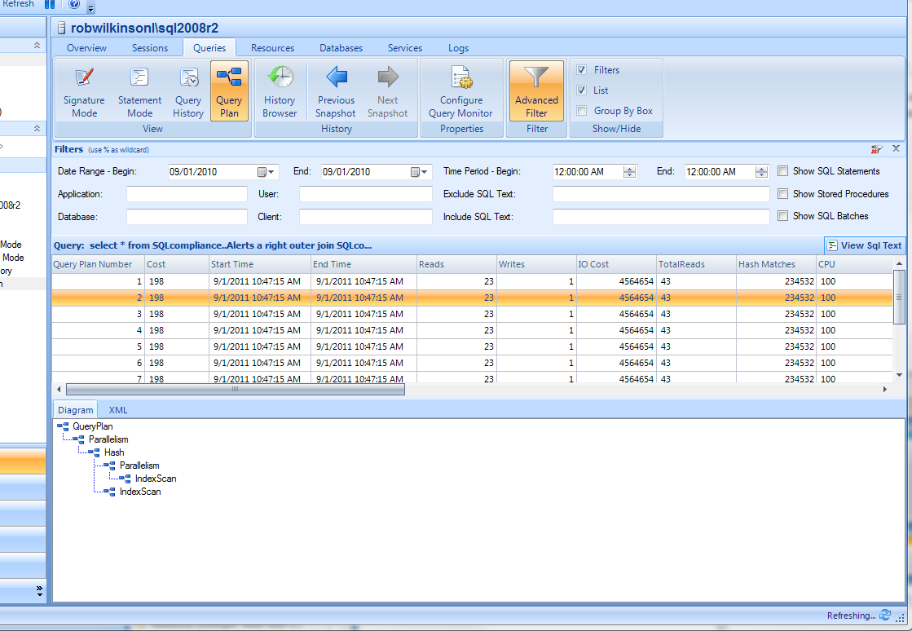

1. There will be a right click menu option that will allow the user to view the plan details or plan differences.

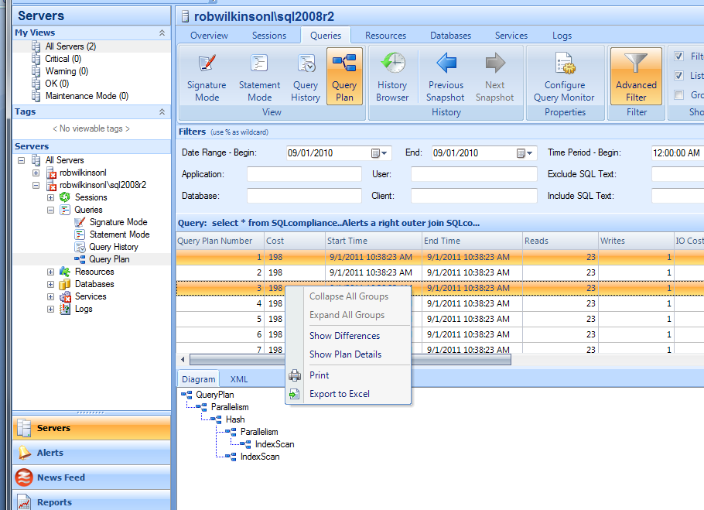

1. The Query Plan details dialog will show the Top Operations for a query and a list of the Query columns.

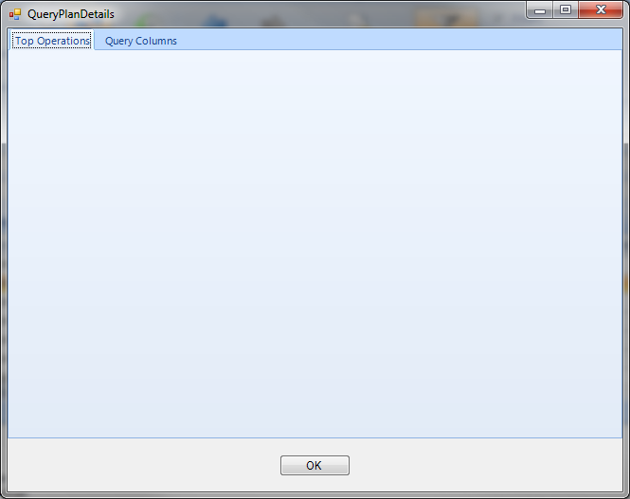

1. The plan differences dialog will allow the user to compare plans using plan diagrams or top operations.

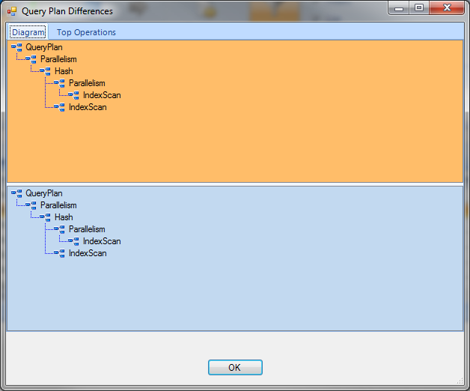

Query monitor settings dialog: There are two options for the dialog.

1. Create a new query plans section

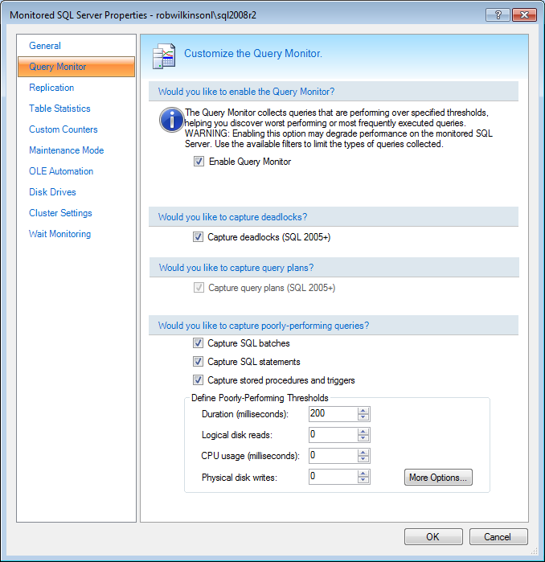

1. Or create a SQL Sever 2005+ section

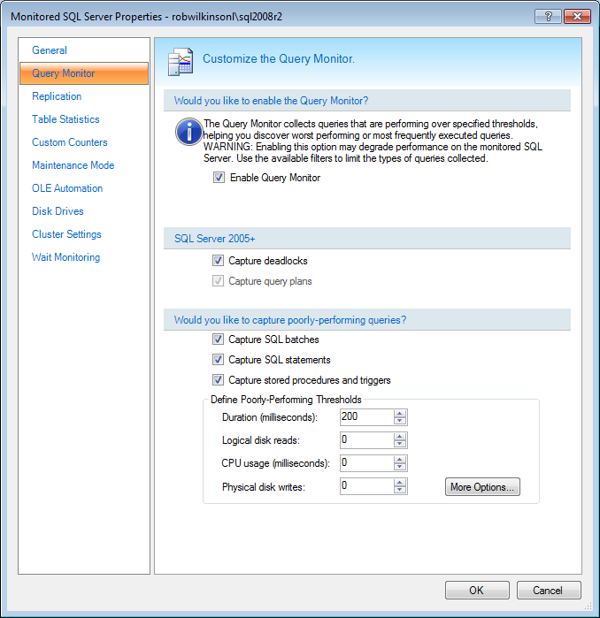

## Installation and Upgrade

The collection of query plan data will be turned off by default.

# Architecture

## Overview

A new view will be created to display query plan information. The plan xml will be retrieved from the plan cache. For SQL Server 2008+, we will use extended events. For SQL Server 2005, we will query the plan cache directly. The plan XML will be stored compressed in the repository.

## Interaction with SQLdm Components

### Desktop Client

See Sections 3.5.1 and 4.1

#### Server Tagging

None

### Repository

A new table will be added to the repository to store the compressed query plans. The table will have a plan Id primary key and the plan xml. The primary key will be added to the query statistics table.

#### Grooming

The old query plan information will be deleted as a part of the query monitor data.

### Management Service

None

#### Alert Reponses

None

### Collection Service

#### Collection

First, a summary of what cannot be used to gather the query plans.

We cannot use traces to get query plans. They cannot be included in the current trace because Showplan_ xml is a different event. Also, they cannot be gathered using an additional trace because the Showplan_ xml event does not contain a duration column.

For SQL Server 2008+, the query monitor will be changed to use extended events. The current SQL Trace will no longer be used

The following will need to be used in the extended event session that will collect the data.

Events:

sqlserver.sql_statement_completed

sqlserver.sp_statement_completed events.

Actions:

sqlserver.client_hostname

sqlserver.client_app_name

sqlserver.plan_handle

sqlserver.sqltext

For login, there are 3 options. It is unclear which one will return the correct username in all cases of if more than one should be used.

sqlserver.username

sqlserver.nt_username

sqlserver.session_nt_username

The data for the exented event will be written to a file target.

Package0.asynchronous_file_target

The file is in a binary format and has to be read by SQL Server. A call to sys.fn_xe_file_target_read_file to get the xml data out of the files.

The extended event will only get us the plan handle. To get the plan you will have to call sys.dm_exec_query_plan and pass it the plan handle.

For SQL Server 2005, we will continue to use the trace. We will query the plan cache for the query plans.

Query fingerprints were added in SQL Server 2008 so they will not help with plan gathering in 2005.

For SQL Server 2000, we will also continue to use the trace but the query plan information is not available. The query plan DMVs do not exist for SQL Server 2000.

#### Eventing

None

### Predictive Analytics Service

None

### Reporting

None

#### Custom Reporting

None

### Custom Counters

None

### SQLdm Mobile

None

### Idera News Feed

None

### Powershell Integration

None

## Supported SQL Server Versions and Editions

This feature will only be available on SQL Server 2005+. SQL Server 2008+ will use extended events. SQL Server 2005 will query the plan cache.

## Install and Upgrade

The collection of query plan data will be turned off by default.

## Permissions and other Required Configuration

### SQLdm Application Security

This will have the same security setting as the query monitor.

### Other Security Considerations

None that I am aware of.

## Licensing Issues

We will to purchase a license for the diagramming software. See 9 in the bibliography.

## Dependencies

### Dependencies on Idera Software

None

### Third-Party Software Required on the Customer Machine

None

### Third-Party Software Required Internally

Yes. The query plan diagramming tool. See 9 in the bibliography.

# Schedule

## Schedule

### Work Breakdown and Sizings

Insert areas that put the implementation or schedule at risk – Assumptions made in design, new areas that have a learning curve etc. Break the project into logical components and add time for design, coding, integration, unit testing. These estimates should not take into account outside forces like maintenance work. These will be applied in building the overall project schedule. A general rule of thumb is to break any unit of work greater then 1 week into smaller pieces to ensure accuracy and to allow measurement of progress during the project.

|  |  |  |
| --- | --- | --- |
| Component | Who | Sizing (Days) |
| New Query Plan view | ? | 5 |
| Plan Differences Dialog | ? | 3 |
| Plan Details Dialog | ? | 2 |
| Collection Server | ? | 5 |
| Repository | ? | .5 |
| Unit and Integration Testing | ? | 2 |
| **Total** |  | **17.5** |

### Areas of Schedule Risk

There is a moderate learning curve with the new diagramming tool and extended events.

# Quality Assurance Considerations

### Overview

Insert explanations for QA considerations that are not apparent from the rest of the specification. Include things like tests on platforms that you want run in greater width then a developer can easily do or which tests you would want as an acceptance test each time a release goes out the door

### Areas of Special Risk

Include areas of special quality risk (as differentiated from schedule risk).

### Platform Considerations

This feature is not available for SQL Server 2000.

### Test Requirements

#### Internationalization Testing

Nothing beyond normal testing.

#### Date/Time Testing

Nothing beyond normal testing.

#### Special Character Testing

Nothing beyond normal testing.

#### Case Sensitive Testing

Nothing beyond normal testing.

#### Stress Testing

Nothing beyond normal testing.

#### Integration Testing

Nothing beyond normal testing.

#### Usability Testing

Nothing beyond normal testing.

#### Security Testing

Nothing beyond normal testing.

#### Recovery Testing

Nothing beyond normal testing.

#### Backward Compatibility Testing

Nothing beyond normal testing.

#### Performance Testing

Nothing beyond normal testing.

# Documentation Considerations

This area TBD

# Bibliography and Works Cited

1. <http://www.sqlskills.com/blogs/jonathan/category/Execution-Plans.aspx> - Example of the plan not being in cache even though the command was just executed.
2. <http://technet.microsoft.com/en-us/sqlserver/video/gg429809> - Extended Events talk
3. <http://technet.microsoft.com/en-us/sqlserver/video/gg429808> - Extended Events demo
4. <http://www.scarydba.com/2011/08/03/all-about-execution-plans-2/> - Links to good query plan articles
5. <http://www.scarydba.com/resources/> - Execution plan resources
6. <http://technet.microsoft.com/en-us/library/ms189602.aspx> - Showplan security
7. <http://schemas.microsoft.com/sqlserver/2004/07/showplan/> - Showplan XML schema
8. <http://www.nwoods.com/components/dotnet/godiagram-overview.htm> - Go Diagram for .Net